Data science
Introduction:
Brain stroke is a life-threatening medical condition that can have severe consequences if not detected and treated promptly. Predicting the risk of stroke is crucial for early intervention and prevention. In this project, we aim to develop a predictive model for stroke risk using a dataset containing various health-related features. The goal is to create a tool that can assist healthcare professionals in identifying individuals at higher risk of stroke and providing them with appropriate care and guidance.

Dataset Overview:
The dataset used for this project consists of the following features:
1. Age: The age of the individual.
2. Gender: The gender of the individual (Male/Female/Other).
3. Hypertension: Whether the individual has hypertension (0 - No, 1 - Yes).
4. Heart Disease: Whether the individual has heart disease (0 - No, 1 - Yes).
5. Marital Status: The marital status of the individual.
6. Work Type: The type of work the individual is engaged in.
7. Residence Type: Whether the individual lives in an urban or rural area.
8. Average Glucose Level: The average glucose level in the individual's blood.
9. BMI: Body Mass Index, a measure of body weight based on height.
10. Smoking Status: The smoking status of the individual (Never smoked, Unknown, Formerly smoked, Smokes).
11. Stroke: The target variable (0 - No stroke, 1 - Stroke)

1. Mounting Google Drive and Importing the csv file.
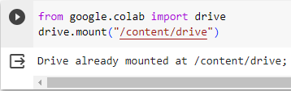
2.Import libraries
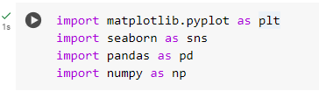
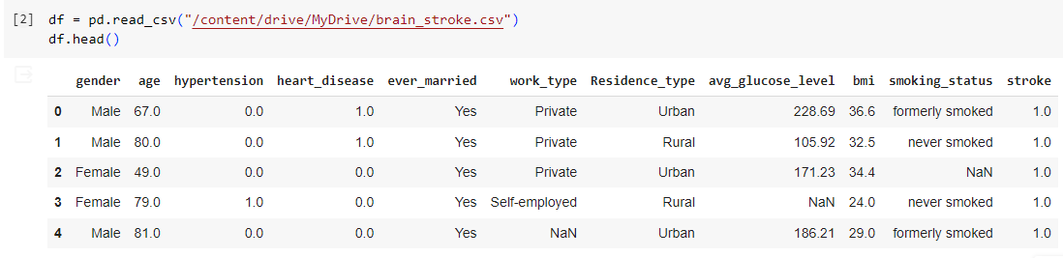

3.Data Manipulation
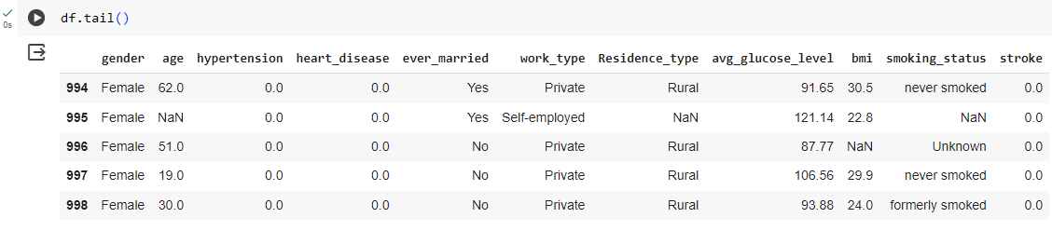

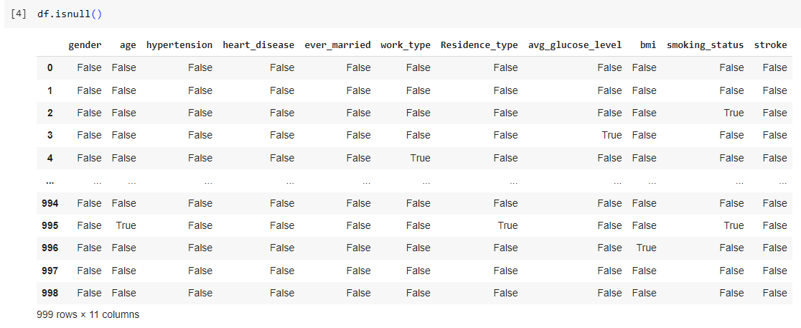

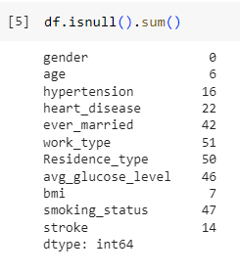

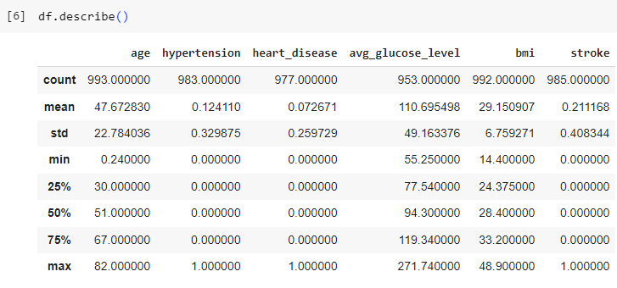

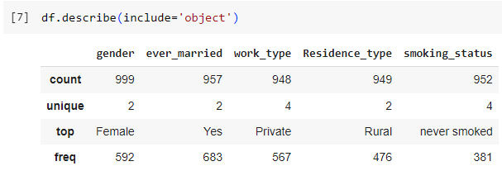

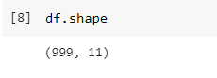
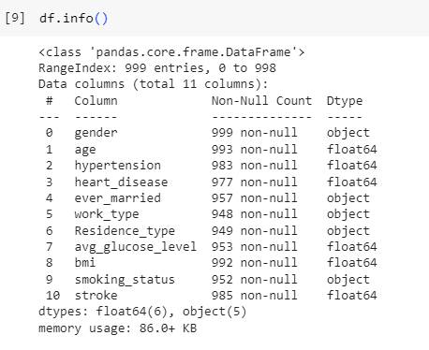

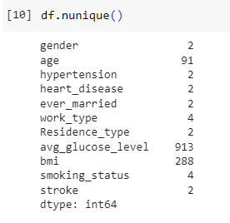

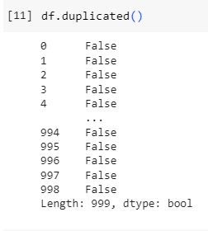
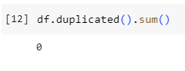
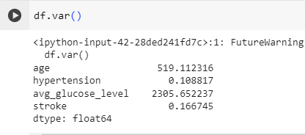

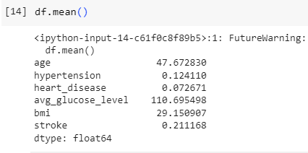

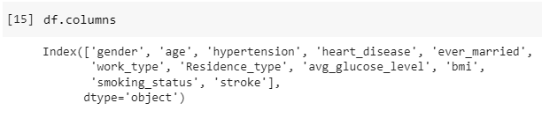

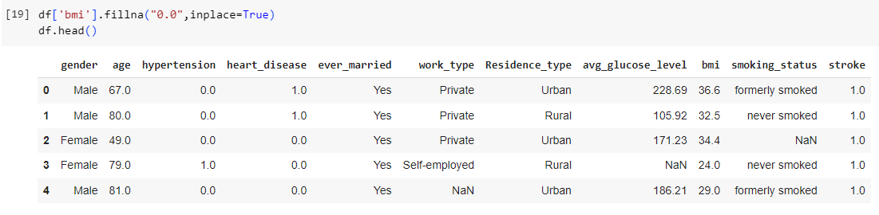

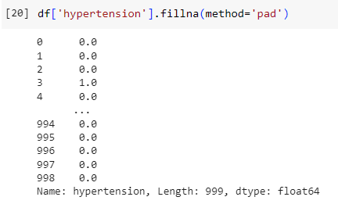

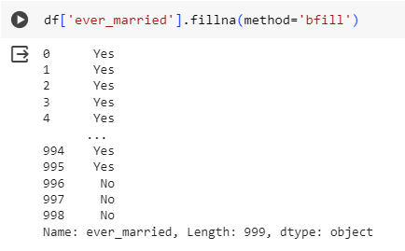
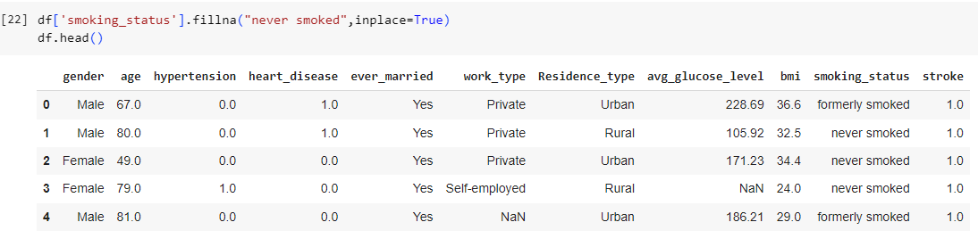
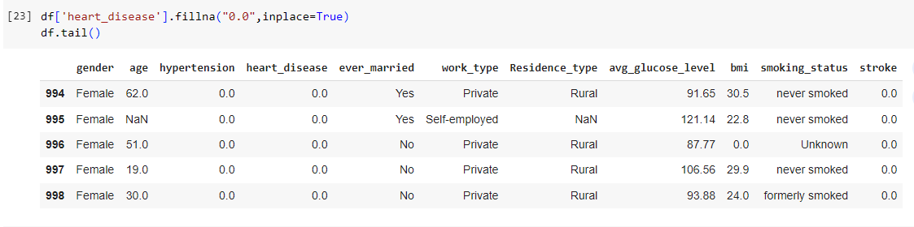

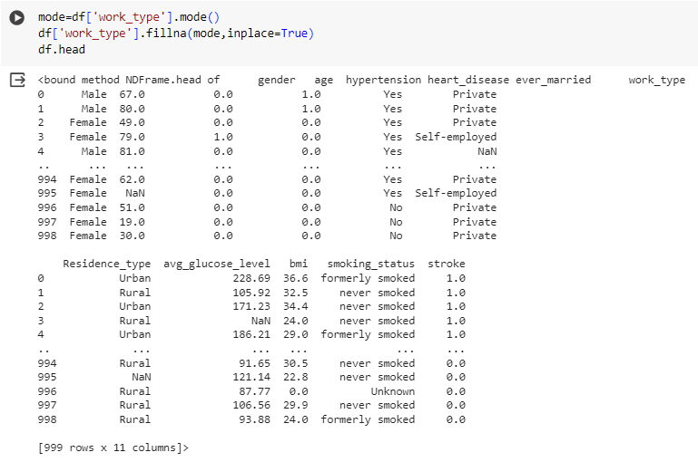

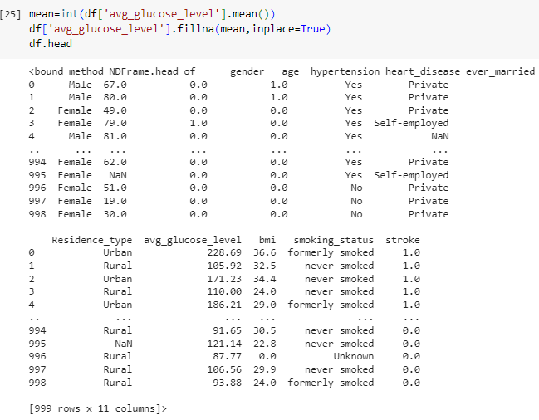

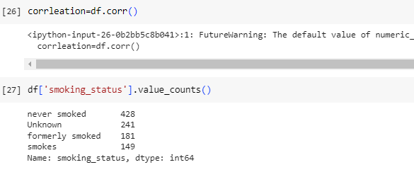
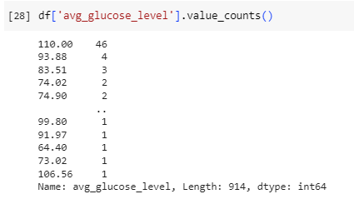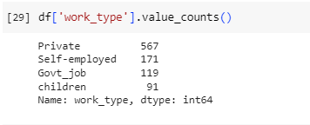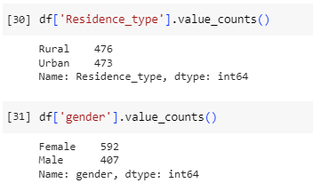

DATA VISUALIZATION
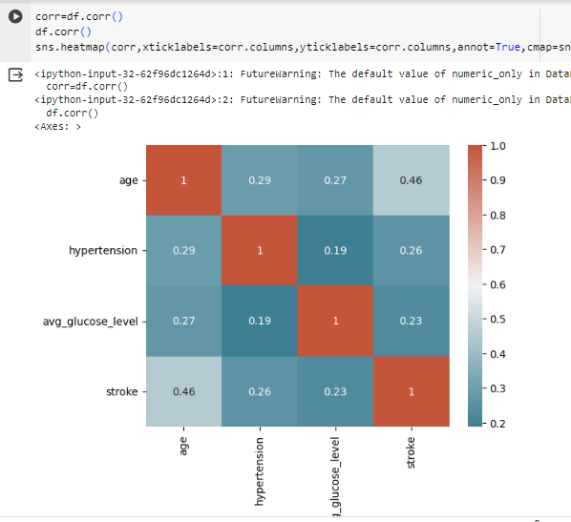

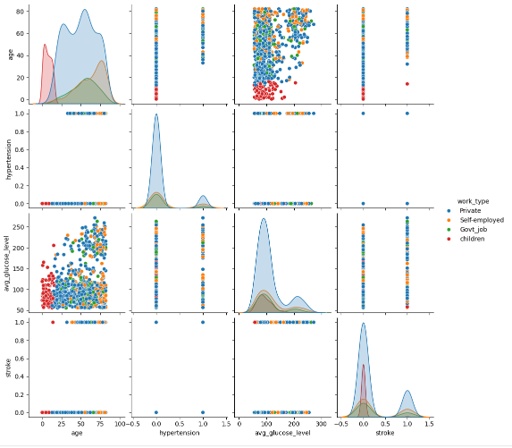
The pairplot provides a comprehensive visualization of the relationships between variables in the dataset, allowing for the identification of patterns, correlations, and potential insights, particularly when comparing different work types.

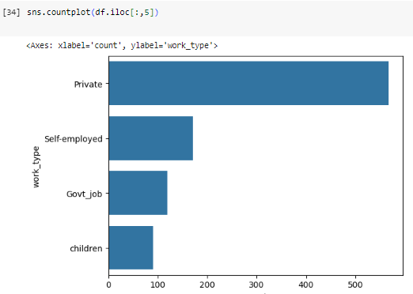
The countplot offers a visual summary of the distribution of categorical data, enabling quick insights into the frequency of different categories within the dataset.

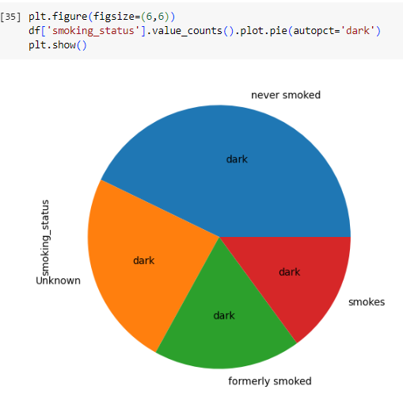
The pie chart offers a visual representation of the distribution of smoking status categories within the dataset, allowing for quick insights into the prevalence of different smoking behaviors among the individuals.

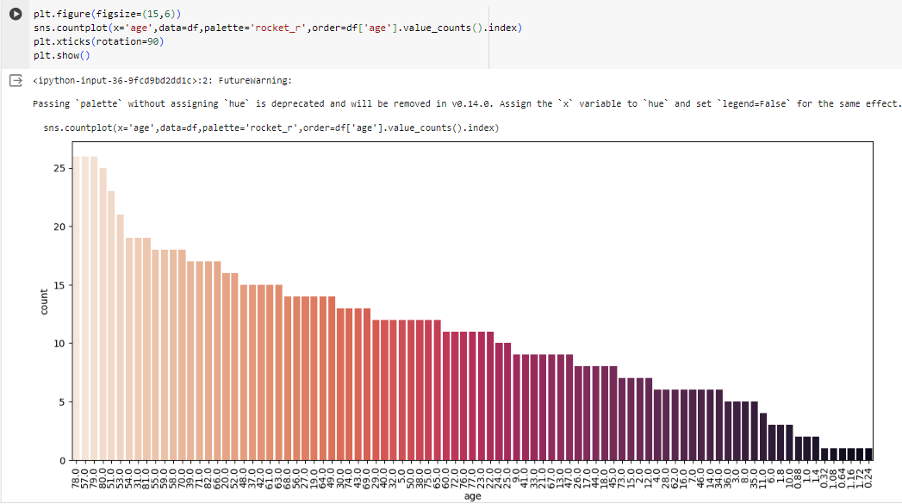

The countplot provides a visual summary of the distribution of ages within the dataset, allowing for quick insights into the age demographics of the individuals included in the analysis.
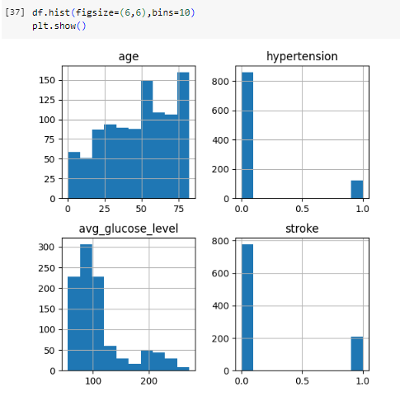

The histograms provide a visual summary of the distribution and characteristics of the numerical variables in the dataset, enabling insights into the underlying patterns and properties of the data.

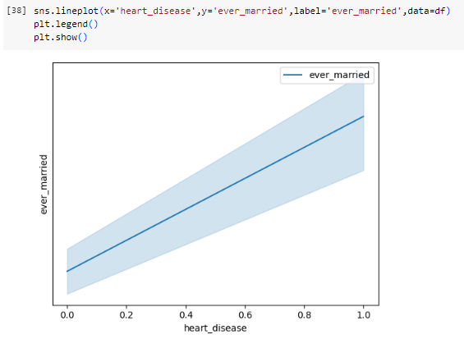

The line plot provides a visual representation of the relationship between the two variables, allowing for insights into potential associations or patterns within the data.
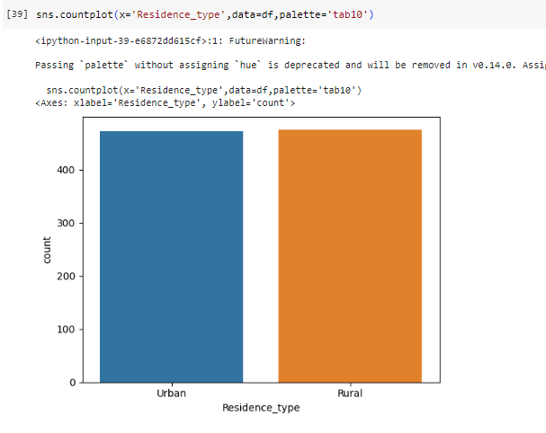

The countplot offers a visual summary of the distribution of residence types within the dataset, facilitating quick insights into the urban-rural distribution among the individuals included in the analysis.

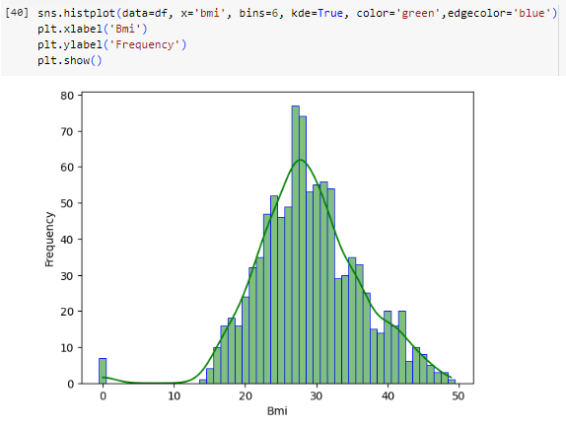
The histogram provides a visual representation of the BMI distribution, enabling insights into the prevalence and characteristics of BMI values among the individuals included in the analysis.
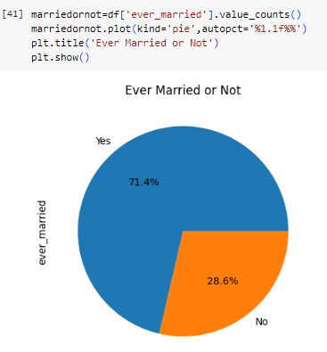

The pie chart offers a visual summary of the distribution of marital status categories within the dataset, facilitating quick insights into the prevalence of different marital statuses among the individuals included in the analysis.

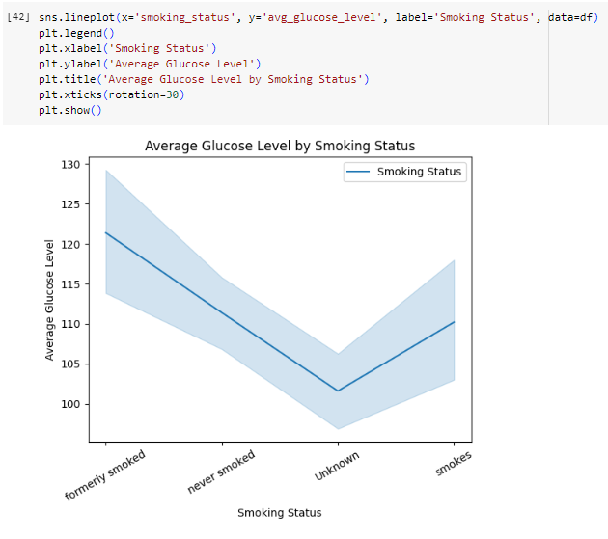
The line plot provides insights into how average glucose levels vary across different smoking status categories, aiding in understanding potential relationships or patterns within the data.

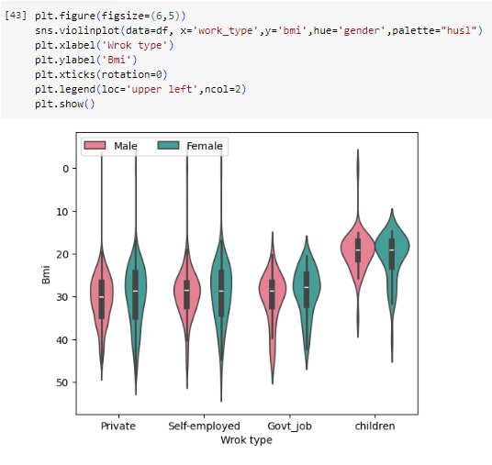
The violin plot provides insights into the distribution of BMI across different work types, with additional differentiation by gender, enabling comparisons and identification of potential patterns or differences within the dataset.

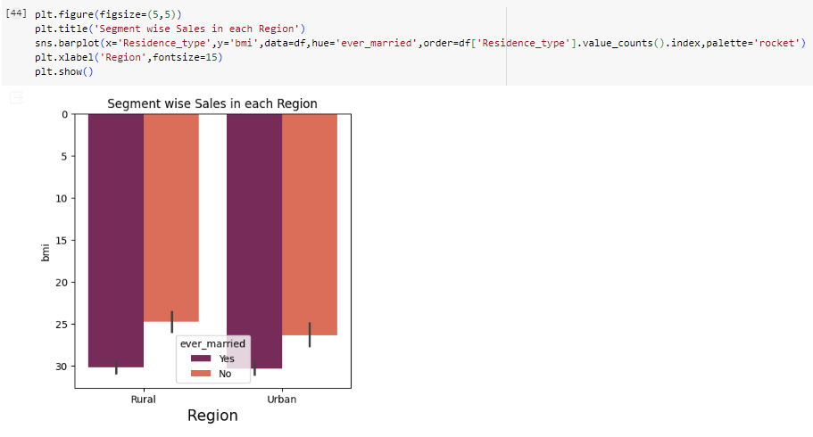
The bar plot allows for comparisons of average BMI between different residence types and marital statuses, providing insights into potential variations in BMI across these demographic factors within the dataset. However, it's important to note the discrepancy in the title, as it might be misleading or require clarification.

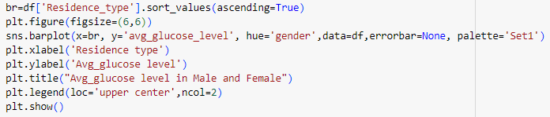
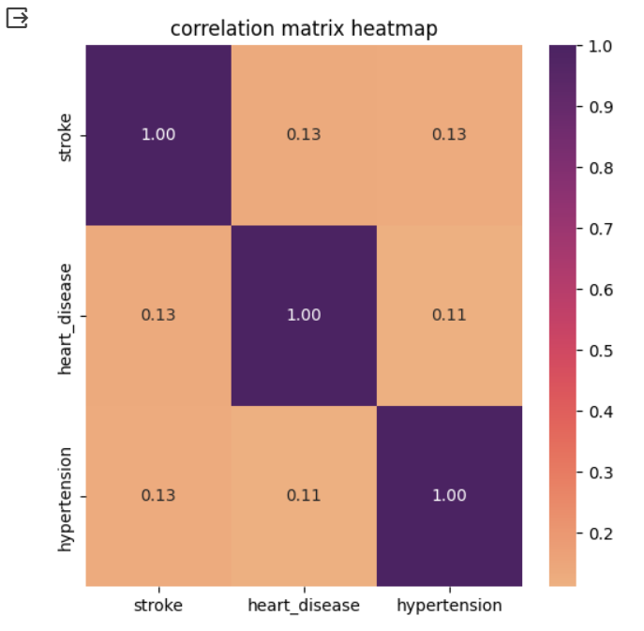
Conclusion:-
There appears to be a weak positive correlation between 'stroke' and 'heart_disease.'
There seems to be no strong linear correlation between 'bmi' and the other variables ('stroke,' 'heart_disease,' 'hypertension').
Correlations close to zero suggest weak linear relationships.

Strategies:
To develop an effective brain stroke prediction model, we will follow these strategies:
1. Data Preprocessing:
- Handle missing values and outliers.
- Encode categorical variables.
- Normalize or standardize numerical features.
2. Exploratory Data Analysis (EDA):
- Visualize the dataset to understand feature distributions and relationships.
- Identify potential patterns or correlations.
- Evaluate class imbalance in the target variable.
3. Feature Selection/Engineering:
- Select relevant features that contribute to stroke prediction.
- Create new features if necessary.
4. Model Selection:
- Experiment with various classification algorithms, such as Logistic Regression, Random Forest, and Gradient Boosting.
- Tune hyperparameters for optimal model performance.
5. Evaluation:
- Use appropriate evaluation metrics (e.g., accuracy, precision, recall, F1-score, ROC-AUC) to assess model performance.
- Address class imbalance using techniques like oversampling or undersampling.
6. Validation:
- Perform cross-validation to ensure the model's generalizability.
- Validate the model on an independent test dataset.
7. Interpretability:
- Analyze feature importance to understand which factors contribute most to stroke prediction.
- Create explainable AI techniques to make the model interpretable for healthcare professionals.

Conclusion:
In conclusion, this project aims to develop a brain stroke prediction model using a dataset of health-related features. Early stroke prediction can significantly improve patient outcomes by enabling timely intervention and prevention strategies. Through careful data preprocessing, feature engineering, model selection, and evaluation, we seek to create a reliable tool for healthcare professionals to assess stroke risk and provide appropriate care to individuals at risk. Effective stroke prediction models can contribute to better healthcare outcomes and ultimately save lives.

